Project - I
Synopsis on
DIGITAL SUPERVISION LAYER FOR INDIA'S PUBLIC DISTRIBUTION SYSTEM (PDS)
COMPUTER ENGINEERING

VI Semester

Submitted by
Jueli Chintawar
Vishwesh Patil
Vansh Barde
Himanshu Mire

Under the guidance of
DR. KAPIL GUPTA
Associate Professor

Academic Year 2025-26



ST. VINCENT PALLOTTI COLLEGE OF ENGINEERING AND TECHNOLOGY
(An Autonomous Institute Affiliated to RTM University, Nagpur)
NAAC Accredited with ‘A’ Grade
Gavsi Manapur, Wardha Road, Nagpur - 441108
ABSTRACT
The Public Distribution System (PDS) is a critical welfare mechanism in India aimed at ensuring food security for economically weaker sections. However, despite ongoing digitization efforts, challenges such as lack of transparency, inefficiencies in distribution, and absence of real-time monitoring continue to affect its performance. Research by Yadav et al. highlights the potential of blockchain technology in improving transparency and reducing intermediaries in PDS, while Drèze and Khera identify key limitations in existing systems, including authentication failures and exclusion issues.
Further studies emphasize the role of emerging technologies in enhancing distribution systems. Patel et al. demonstrate how IoT-based smart ration systems can improve automation and tracking, though they lack secure audit mechanisms. Additionally, Singh and Sharma suggest that hybrid architectures combining traditional databases with decentralized technologies offer better scalability and efficiency for government welfare systems.
Based on these insights, this project proposes a Digital Supervision Layer for PDS that enhances accountability without replacing the existing infrastructure. The system is developed using the PERN stack and incorporates OTP-based authentication, a wallet-based entitlement mechanism, and role-based access control for secure operations. It also utilizes a hash-linked ledger to maintain tamper-evident transaction records.
The proposed solution aims to improve transparency, reduce operational inefficiencies, and enable better monitoring of the distribution process. By integrating proven concepts from existing research into a practical and scalable system, the project contributes toward strengthening governance in the Public Distribution System.

CONTENTS

Sr. No. | Contents | Page No.
1 | Introduction | 1-2
2 | Problem statement and objectives | 3-4
3 | Literature Review | 5-8
4 | Proposed Methodology | 9-10
5 | Software and Hardware Requirement | 11
6 | Expected outcome | 12-13
7 | References | 14

- INTRODUCTION

1.1 OVERVIEW
The Public Distribution System (PDS) is a flagship welfare initiative of the Government of India that plays a vital role in ensuring food security for economically vulnerable sections of the population [5]. Under the National Food Security Act (NFSA), millions of beneficiary households across the country receive subsidized food grains including rice, wheat, and coarse cereals through a nationwide network of Fair Price Shops (FPS). The PDS serves as one of the world's largest food distribution networks [7], making its efficiency and integrity critical to national welfare delivery.
In recent years, significant digitization efforts have been undertaken to modernize the PDS. The introduction of electronic Point of Sale (e-POS) machines, Aadhaar-linked biometric authentication, and centralized databases has improved beneficiary identification and transaction recording. The One Nation One Ration Card (ONORC) initiative [8] further extended portability of ration access across state boundaries, enabling migrant workers and mobile populations to claim their entitlements from any FPS in the country.
Despite these advancements, critical gaps persist in the system. Existing digital measures primarily address authentication and transaction logging, but fall short in verifying the actual quantity of goods dispensed [1], detecting fraudulent activities in real time, and maintaining tamper-proof records of distribution activities. Issues such as stock diversion, short weighing, dealer-level manipulation, and lack of real-time supervisory oversight [6] continue to undermine the effectiveness of the PDS.
1.2 MOTIVATION
The motivation for this project stems from the need to bridge the gap between transaction recording and physical distribution verification in the PDS. While current systems confirm that a transaction occurred, they do not validate whether the correct quantity of commodities was actually delivered to the beneficiary. This creates an enforcement gap that can be exploited through short weighing and fraudulent dealer practices [1], [6].
Emerging technologies such as IoT-based measurement devices [2], [6], blockchain-based immutable ledgers [1], [4], and AI-driven anomaly detection models [3] present an opportunity to design a supervisory layer that addresses these shortcomings without requiring a complete overhaul of the existing infrastructure. The proposed system is motivated by the need to enhance governance, transparency, and accountability in India's PDS through a practical, scalable, and non-intrusive technology integration [5].
1.3 SCOPE OF THE PROJECT
The scope of this project encompasses the design, development, and feasibility demonstration of a Digital Supervision Layer for the PDS. The system integrates entitlement-based digital wallets, IoT-verified dispensing mechanisms [2], [6], cryptographic hash-linked audit logging [1], [4], AI-based anomaly detection [3], and a multi-role administrative dashboard. The project aims to demonstrate end-to-end functionality using synthetic data while ensuring compatibility with the existing PDS infrastructure and government policy guidelines [5].

- PROBLEM STATEMENT AND OBJECTIVES
2.1 PROBLEM STATEMENT
The Public Distribution System (PDS) in India faces persistent challenges despite ongoing digitization efforts [5][8]. While e-POS systems and Aadhaar-based authentication have improved beneficiary identification and transaction recording, several critical operational gaps continue to affect the system's effectiveness and integrity [6].
Existing systems primarily record that a transaction has occurred but do not verify the actual quantity of commodities dispensed at the point of distribution [1][4]. This absence of physical validation enables fraudulent practices such as short weighing, where beneficiaries receive less than their entitled quantity. Additionally, stock diversion at the dealer level, delayed reconciliation between allocated and distributed stocks, and lack of real-time supervisory intelligence further compromise welfare delivery [5].
There is no tamper-evident audit mechanism in place to ensure that recorded transactions cannot be altered post-distribution [9][2]. The absence of intelligent anomaly detection means that suspicious patterns in distribution data go undetected [3]. Therefore, there is a clear need for a system that ensures accurate quantity validation, real-time monitoring, tamper-proof audit logging, and improved governance in PDS operations without disrupting the existing infrastructure [1][2][4].
2.2 OBJECTIVES

1.Development of Digital PDS System
To design and develop a digital Public Distribution System using the PERN stack that replaces manual ration management with a structured and role-based workflow for administrators, shopkeepers, and beneficiaries, ensuring efficient system operations [1][6].

2. Automated Entitlement Allocation

To implement an automated entitlement engine that calculates and distributes monthly ration quotas such as rice, wheat, and sugar into beneficiary wallets based on NFSA category rules (AAY, BPL, APL), reducing manual errors and improving accuracy[5][8].

3. Enhanced Security and Transparency
To improve system security and transparency by integrating OTP-based authentication, JWT-based role-based access control (RBAC), and a blockchain-supported audit layer to ensure secure access and tamper-proof transaction records[2][9].

4. Smart Distribution Mechanism
To build an end-to-end smart distribution system by developing dedicated interfaces for beneficiaries and shopkeepers, enabling efficient ration distribution and real-time transaction verification[4][6].

5. Intelligent Monitoring and Anomaly Detection
To incorporate an intelligent monitoring system using data analytics and anomaly detection techniques to identify irregular distribution patterns, prevent fraud, and enhance decision-making for authorities [3][2].

- LITERATURE REVIEW
A comprehensive review of existing literature reveals several technological advancements aimed at improving the efficiency, transparency, and security of the Public Distribution System (PDS). Various researchers have explored the use of Blockchain, IoT, Aadhaar authentication, and decentralized systems to address issues such as fraud, inefficiency, and lack of accountability. The following studies provide significant insights and form the foundation for the proposed system.

3.1 Blockchain-Based Public Distribution System
Yadav et al. (2021)[1] proposed a blockchain-based framework utilizing Ethereum smart contracts to ensure transparency and eliminate intermediaries in food grain distribution. Their approach stored beneficiary and transaction data directly on the blockchain, ensuring immutability and traceability of records.
However, the study identified key limitations such as high transaction costs, scalability issues, and network latency associated with public blockchain systems.
To address these challenges, the proposed system adopts a hybrid architecture, where operational data is stored in PostgreSQL for efficiency, while only cryptographic transaction hashes are recorded on the blockchain. This approach ensures cost-effectiveness, scalability, and audit integrity.

3.2 Aadhaar-Based Authentication in PDS
Dreze and Khera (2017)[5] analyzed the impact of Aadhaar-based biometric authentication in the PDS and found that it significantly reduced duplicate and fake beneficiaries. This contributed to improved targeting and reduced leakage in the system.
However, the study also highlighted several practical issues such as authentication failures due to poor internet connectivity, biometric mismatches, and system downtime. These issues often resulted in the exclusion of genuine beneficiaries.
To overcome these limitations, the proposed system introduces QR-based authentication with OTP fallback, ensuring reliable verification even in low-connectivity environments and improving accessibility.
3.3 Smart Ration Card System Using RFID and IoT
Patel et al. (2020)[6] developed an RFID-based smart ration card system integrated with IoT technology to automate inventory tracking and transaction management at Fair Price Shops. This system reduced manual errors and improved operational efficiency.
However, it lacked a secure audit mechanism, making it vulnerable to post-transaction data manipulation and fraud.
The proposed system improves upon this model by replacing RFID with QR-based digital identity and incorporating a cryptographic hash-linked ledger, ensuring tamper-proof and verifiable transaction records.

3.4 Decentralized Applications for Welfare Systems
Singh and Sharma (2022)[7] examined decentralized application architectures for government welfare programs and concluded that fully blockchain-based systems suffer from performance bottlenecks and scalability issues.
The study recommended a hybrid approach, combining traditional databases with blockchain technology to achieve optimal performance and transparency.
This finding directly supports the design of the proposed system, which integrates PostgreSQL for high-speed transactions and blockchain for immutable audit logging, achieving a balance between efficiency and security.

3.5 One Nation One Ration Card Implementation Challenges
A report by the Ministry of Consumer Affairs (2023)[8] on the One Nation One Ration Card (ONORC) initiative highlighted several operational challenges, including:
- Lack of real-time transaction validation
- Inability to detect duplicate claims across regions
- Delayed updates in entitlement records
These issues reduce the effectiveness of the system and create opportunities for misuse.
The proposed system addresses these challenges through real-time wallet deduction, QR-based beneficiary validation, and an automated entitlement allocation engine, ensuring accuracy and synchronization across the system.

3.6 Bitcoin and Hash-Based Ledger Systems
Nakamoto (2008)[9] introduced the concept of a decentralized and tamper-resistant ledger using cryptographic hashing and chained blocks, forming the foundation of blockchain technology. This model ensures immutability, transparency, and non-repudiation of transactions.
The proposed system applies these principles in a controlled environment by implementing a SHA-256 hash-linked ledger, which provides tamper-evident audit trails without the overhead of a fully decentralized blockchain network.

3.7 Blockchain and IoT for Supply Chain Management
Ahmad et al. (2024)[2] presented an integrated framework combining IoT and blockchain technologies for secure and transparent supply chain management in smart cities. The study demonstrated that IoT enables real-time data collection, while blockchain ensures data integrity and traceability.
This approach significantly improves monitoring and reduces fraud in distribution networks.
The proposed system adopts a similar integration by combining IoT-based weight validation with cryptographic logging, enabling end-to-end verification of ration distribution.

3.8 Digital Governance and PDS Monitoring Systems
Reports from organizations such as the National Informatics Centre (NIC) and Food Corporation of India (FCI)[5][7] emphasize the importance of digital transformation in the PDS through technologies like e-POS systems, centralized databases, and monitoring dashboards.
While these systems improve record-keeping and reporting, they lack:
- Real-time quantity verification
- Advanced analytics for fraud detection
- Tamper-proof audit mechanisms
The proposed system builds upon these existing solutions by introducing IoT-enabled dispensing validation, AI-based anomaly detection, and secure audit logging, thereby enhancing overall transparency and governance.

- PROPOSED METHODOLOGY
The proposed system introduces a blockchain and IoT-integrated Digital Public Distribution System (PDS) designed to eliminate inefficiencies, fraud, and lack of transparency in traditional ration distribution [1][2][4]. The system follows a modern full-stack architecture using the PERN stack and is built on three core principles: secure digital transactions, automated entitlement enforcement, and verifiable auditability. It replaces manual processes with an end-to-end digital pipeline where every transaction is recorded in a database and anchored on a blockchain for trust [9].
The system architecture is divided into multiple layers, including IoT-based physical measurement, application interfaces, data storage, and blockchain audit. The Admin Panel manages beneficiary registration, entitlement allocation, and shop mapping. The Shopkeeper Panel handles QR-based authentication and transaction processing, while the Beneficiary Application provides secure OTP login, wallet access, and QR generation. PostgreSQL manages operational data, while blockchain ensures immutable transaction records [1][2].
Blockchain is implemented as a trust layer rather than a data storage replacement. All critical transactions, such as ration distribution and monthly allocation, are recorded on the Ethereum Sepolia network using smart contracts [1]. Sensitive beneficiary data remains off-chain to ensure privacy, while hashed identifiers, transaction details, and timestamps are stored on-chain to provide tamper-proof auditability [9]. This hybrid approach balances efficiency, security, and transparency [2].
IoT integration ensures physical validation of ration distribution. A smart weighing unit built using ESP32, load cell, and HX711 module measures the exact quantity of grains dispensed [2][6]. The system validates these readings in real time and only allows transaction confirmation when the measured weight matches the allocated entitlement within a defined tolerance. This eliminates discrepancies between recorded and actual distribution, preventing malpractice at the shop level [4].
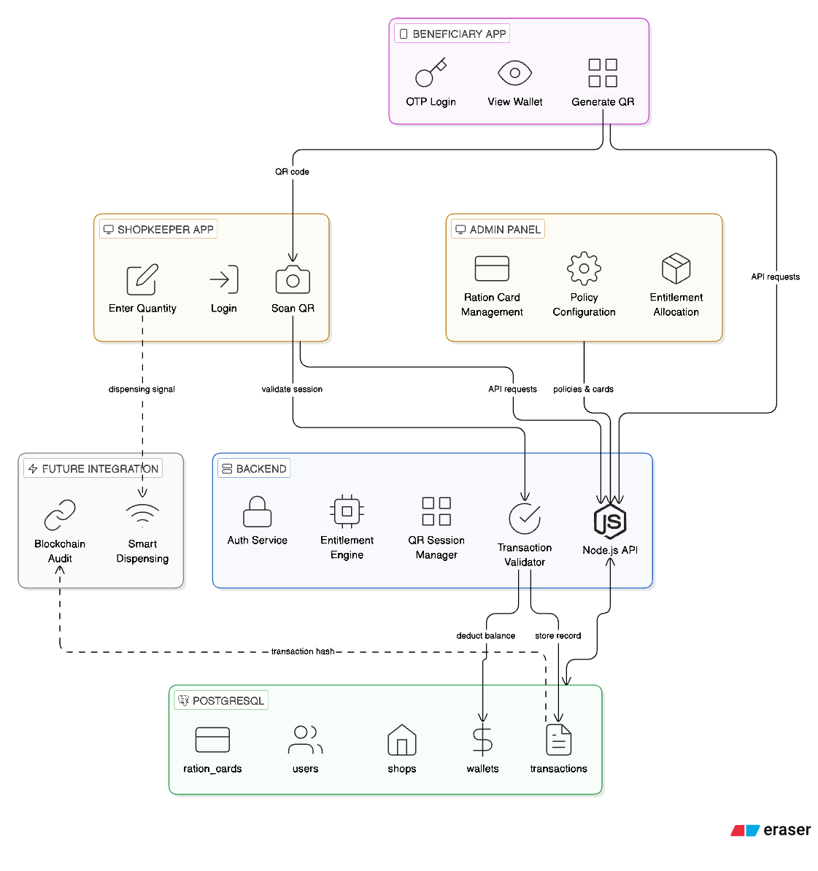
The system also incorporates an automated entitlement engine and secure authentication mechanisms. Monthly ration allocation is computed based on government policies and updated atomically in the database [5][8]. Role-Based Access Control (RBAC) ensures restricted system access for admins, shopkeepers, and beneficiaries. QR-based authentication with time-bound encrypted tokens prevents misuse, while blockchain-backed transaction records and IoT verification collectively ensure a transparent, secure, and reliable ration distribution system [1][3][9].

Fig 1: Proposed Methodology for PDS

- SOFTWARE AND HARDWARE REQUIREMENT
5.1 SOFTWARE REQUIREMENTS
- FRONTEND TECHNOLOGIES
- BACKEND TECHNOLOGIES
- DATABASE SYSTEMS
- CRYPTOGRAPHIC LEDGER
- AI AND ANALYTICS
- SECURITY AND DEPLOYMENT TOOLS
5.2 HARDWARE REQUIREMENTS
- MICROCONTROLLER / DEVELOPMENT BOARD
- LOAD CELL SENSOR AND HX711 AMPLIFIER
- IOT COMMUNICATION MODULE
- USER DEVICES
- SERVER SYSTEM
- DISPLAY UNIT (OPTIONAL)
- POWER SUPPLY

- EXPECTED OUTCOMES
6.1 PERFORMANCE EXPECTATIONS
The proposed system is expected to deliver the following measurable performance outcomes:
- Transaction Accuracy: The system is expected to achieve 100% accurate digital recording of all distribution transactions, enabled by automated IoT weight validation and strict deviation control mechanisms that prevent short weighing and incorrect quantity recording.
- System Latency: Real-time QR-based beneficiary authentication, entitlement validation, and IoT weight verification are expected to complete within acceptable time limits, ensuring smooth and efficient distribution at Fair Price Shops without causing delays.
- Ledger Integrity: The cryptographic hash-linked ledger is expected to provide a fully tamper-proof and verifiable audit trail, ensuring that no transaction record can be altered or deleted once committed to the system.
- Anomaly Detection Accuracy: The AI-based anomaly detection module is expected to identify irregular distribution patterns with high accuracy and low false positive rates, providing reliable risk scoring for administrative review.
- Security and Access Control: Role-based access enforcement, JWT authentication, and TLS encryption are expected to prevent all unauthorized transactions, data breaches, and privilege escalation across all system modules.
6.2 PRACTICAL AND GOVERNANCE EXPECTATIONS
Beyond technical performance, the system is expected to deliver the following practical and governance-level outcomes:
- Feasibility Demonstration: The system is expected to demonstrate successful integration of the digital wallet, IoT dispensing validation, cryptographic ledger, and AI anomaly detection modules into a cohesive multi-layer architecture with smooth inter-module interaction[2][3][4].
- Operational Transparency: Real-time visibility of entitlement balances, distribution activities, transaction audit logs, and risk monitoring data is expected to significantly improve accountability for administrators, shopkeepers, and beneficiaries[1][2].
- Improved Monitoring and Reconciliation: Data-driven supervision through the administrative dashboard, automated anomaly alerts, and structured audit logs are expected to enable faster reconciliation of stock allocation and distribution records[3][5].
- Governance Strengthening: Tamper-evident transaction records, programmable entitlement enforcement, and data-backed inspection capabilities are expected to reduce opportunities for fraud and improve overall governance of the PDS[1][4][9].
- Scalability and Adaptability: The modular system architecture is expected to support scaling to larger beneficiary datasets, additional commodity types, integration with other government welfare schemes, and adaptation to evolving infrastructure requirements[2][7][8].

REFERENCES

- Raghunandan, Arpitha, and Alisa Priyadarsini. "Scalable Blockchain Solution for Targeted Public Distribution System (TPDS) in India." 2021 5th International Conference on Intelligent Computing and Control Systems (ICICCS). IEEE, 2021.
- Ahmad, Ahmad Yahiya Ahmad Bani, et al. "An IoT and blockchain-based secure and transparent supply chain management framework in smart cities using optimal queue model." IEEE Access 12 (2024): 51752-51771.
- Chang, Haotian, Jing Feng, and Chaofan Duan. "HADIoT: A hierarchical anomaly detection framework for IoT." IEEE Access 8 (2020): 154530-154539.
- Agarwal, Udit, et al. "Blockchain-based intelligent tracing of food grain crops from production to delivery." Peer-to-Peer Networking and Applications 17.6 (2024): 3722-3749.
- Drèze, Jean, and Reetika Khera. "Recent social security initiatives in India." World Development 98 (2017): 555-572.
- Shukla, Subhasini, Akash Patil, and Brightson Selvin. "A step towards smart ration card system using RFID & IoT." 2018 International Conference on Smart City and Emerging Technology (ICSCET). IEEE, 2018.
- Sellers, Jefferey M., and Anders Lidström. "Decentralization, local government, and the welfare state." Governance 20.4 (2007): 609-632.
- Rajput, Kuldeepsingh. "Towards Inclusion by Food Security for Migrants: An Overview of ‘One Nation, One Ration Card’Scheme."
- Nakamoto, Satoshi. "Bitcoin: A peer-to-peer electronic cash system." (2008).Nakamoto, Satoshi. "Bitcoin: A peer-to-peer electronic cash system." (2008).

UID Name of the student Signature

23001016 Juel Chintawar
23001114 Vishwesh Patil
23001085 Vansh Barde
23001066 Himanshu Mire

Date :
--------------------------------------------------------------------------------------------------------------
Name of the guide : Kapil Gupta
Signature with date :

Remarks :

--------------------------------------------------------------------------------------------------------------
Sign of HOD : Date:

Remarks :

